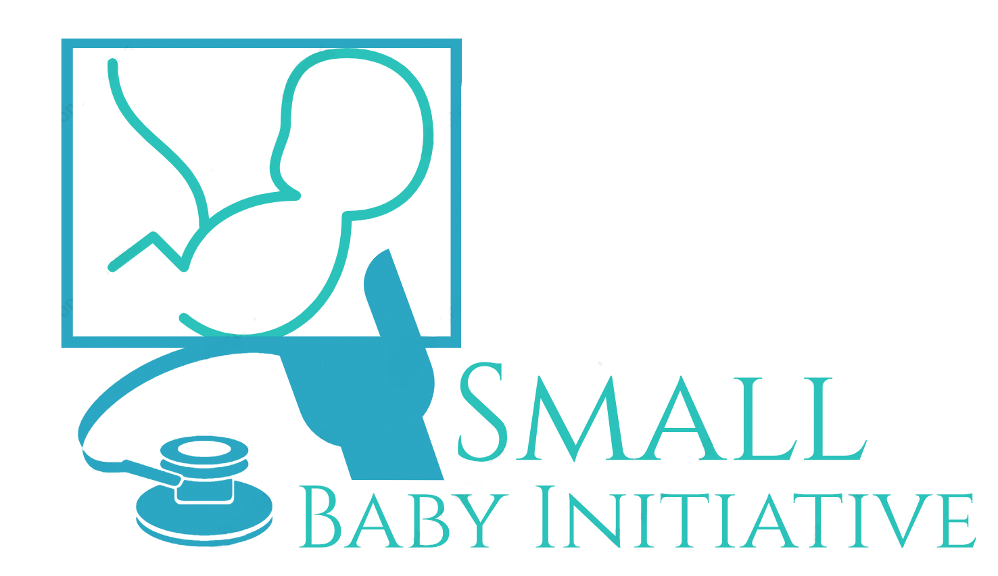_______________________________________________________________________________
Title: Bubble CPAP troubleshooting
Designated Clinical Areas: Blake 10 NICU
Level of Personnel: RN, RT, MD, NNP

No BUBBLING in the chest?

Check your FACE!!

Fit: | - Parallel to face (using foam blocks)  - Not too tight/too loose  - Correct size  - Mask/prong too old and collapsing?
Abdominal distention: | - Upsize OG (8fr best)  - Lower flow? (10L is baseline)  - Milk or secretions in OG and preventing venting?
Chin strap: | - Encourages mouth closure
Evacuate nares & O/P: | - Suction nares using “Baby Neti Pot technique” (NS drops in one nares and suction opposite nares shallowly with Webe/Bebeonker)  - Suction back of O/P

