Data for Improvement: Control Chart Tools
Control Chart Selection Guide
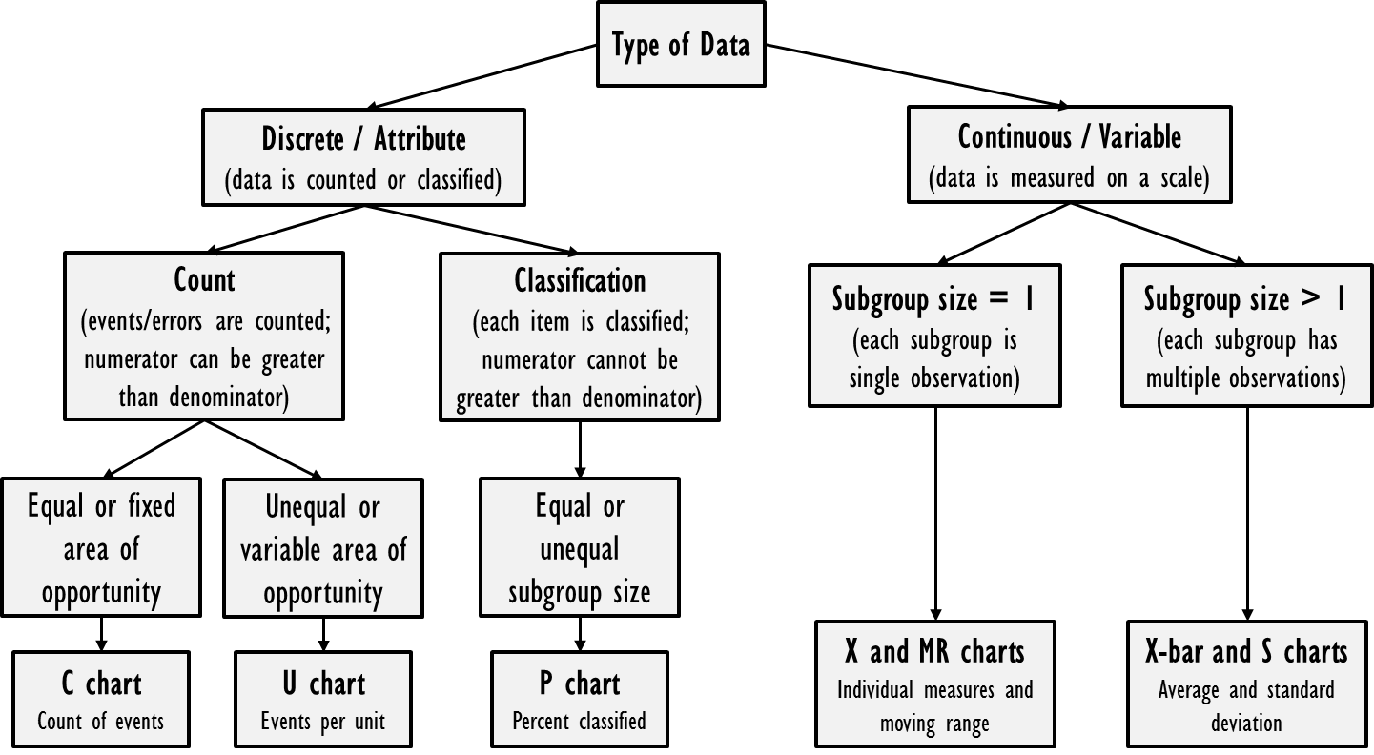Gupta and Kaplan, Clinics in Perinatology, 2017, 44 (3):627-644.
Rule-Based Conventions for Special Cause Variation in Control Charts
Selected Author Recommendations
 | Provost and Murray | Benneyan | Carey | Montgomery
One or more points more than 3 SD from the mean | ✓ | ✓ | ✓ | ✓
2 of 3 consecutive points more than 2 SD from the mean | ✓ | ✓ | ✓ | ✓
4 of 5 consecutive points more than 1 SD from the mean |  | ✓ |  | ✓
8 consecutive points on one side of the mean | ✓ | ✓ | ✓ | ✓
6 consecutive points increasing or decreasing | ✓ | ✓ | ✓ | ✓
15 consecutive points within 1 SD of the mean | ✓ |  |  | ✓
14 consecutive points alternating up and down |  | ✓ |  | ✓
8 points in a row more than 1 SD from the mean |  |  |  | ✓
Provost LP and Murray SK, The Health Care Data Guide, 2011
Benneyan JC et al, Qual Saf Health Care, 2003, 12(6):458-464
Carey RG, Improving Healthcare with Control Chart: Basic and Advanced SPC Methods and Case Studies, 2003
Montgomery DC, Introduction to Statistical Quality Control, 7th ed, 2013

