**Table of Contents**



**NeoQIC**

**REDCap User Manual**

May 17, 2021

I. Introduction 3

II. Contact Information 3

III. General Overview of the Project 3

IV. General Overview of the Website 3

REDCap System 4

V. Background about REDCap 4

Background 4

Additional Information about REDCap 4

VI. Accessing REDCap 4

New user requests 4

Permissions 6

Logging in 6

Two-Factor Authentication (2FA) 7

DUO 8

Google Authenticator 9

Email 9

Account suspension and REDCap downtime 9

Account suspension 9

Website timing out 10

Maintenance periods 10

Accessing the NeoQIC project 10

Navigation within the NeoQIC project 11

Accessing data 14

Navigation Tips 16

VII. Data Entry 16

Data entry tips 16

Saving data 17

Useful data entry features 19

Enter a new participant: step by step instructions 22

VIII. Using the Day of Life Table 24

Introduction 24

Creating a Record 24

Recording Data 25

The Day of Life Table 26

IX. Sending Out Survey Invites 29

The Enrollment Form 29

Viewing Alerts / Surveys Scheduled 30

X. Data Cleaning and Reports 31

Data quality checks 32

Reports 33

# Introduction

The objective of this user manual is to provide an easy-to-follow, step-by-step guide to data entry for the REDCap data entry web system for the NeoQIC project, as created by the Boston University School of Public Health Biostatistics and Epidemiology Data Analytics Center (BEDAC).

The REDCap URL for capturing interview surveys and chart abstractions for the study is: <https://redcap.bumc.bu.edu/>

The TEST project name is:

NeoQIC - FOR PRACTICE ONLY

The LIVE project name is:

**NeoQIC**

Users will be temporarily granted access to the TEST project for training purposes, or upon special request. Otherwise, the BEDAC team encourages users to only have access to the LIVE project to reduce potential errors in saving forms to the wrong project. However, if users want to see how the project will behave under certain scenarios, these tests should occur in the test project and not the live project.

# Contact Information

For questions regarding the website or study data, please contact any of the following people at the Boston University BEDAC:

**[BMC NeoQIC team member]**, *BMC team* **[Primary Contact]**

Phone:

Email:

**Clara Chen**, *BUSPH Project Manager*

Phone: 617.358.7897

Email: cachen@bu.edu

# General Overview of the Project

The NeoQIC survey involves multiple sites. Each site will have staff who will consent participants for emailed or texted surveys and abstract chart review data, and BMC site coordinators who will be additionally be responsible for data cleaning. The Boston University BEDAC group will continue to provide data management and analytic support.

The NeoQIC project contains a chart abstraction form completed by site staff, and two post-discharge surveys completed by participants.

# General Overview of the Website

The project utilizes the REDCap system to collect participant interview surveys and integrate data cleaning and some basic reporting functionality.

All sites will use the same website for data collection purposes, but each site will only be able to see their own site’s participants and associated information. The BMC team will have access to all sites’ data, as the central data coordinating center. The BEDAC team will have access to all data collected from the websites as the group that created and maintains the REDCap project.

## REDCap System

The chart reviews and participant surveys will be entered into the REDCap data collection system. Data cleaning is integrated into this system, and sites will be able to identify and clean their own data queries. Some basic reporting on site-specific responses is also available directly in the REDCap system.

# Background about REDCap

## Background

REDCap (*R*esearch *E*lectronic *D*ata *Cap*ture) is a secure, web-based application designed exclusively to support data capture for research studies. It was developed at Vanderbilt University and includes more than 1.2 million projects with 5,099 active institutional partners in 141 countries.

The main advantage to using electronic data capture is that skip patterns are built directly into the interviews, enabling the interviewer to concentrate on the participant and his/her responses, rather than trying to follow the directions on a paper questionnaire. There are also interviewer prompts to help the flow of the interviews. Alerts are programmed into the system to warn you of data entry errors. Reports are available to identify discrepancies and data cleaning, which can be cleaned directly in REDCap. All of this will result in easier interviews and more accurate data.

## Additional Information about REDCap

REDCap is fairly intuitive and easy to use. If you are interested in learning more about the software, you may like to investigate the comprehensive documentation and instructional videos available on the REDCap website (<http://project-redcap.org/>). Though much of the information is geared toward programmers, you will also find general information that may be of interest to you.

# Accessing REDCap

## New user requests

Access to REDCap must be requested through the BMC NeoQIC team (see contact info above, in section II. Contact Information). For users new to REDCap, an online End-User License Agreement (EULA) should be completed. This online EULA is linked to the main login page of the BU installation of REDCap. Access to REDCap may be granted when the electronically signed EULA is returned to BU and processed; this process may take up to 4-5 business days following submission of the online EULA form.

When the REDCap account is created, the new user is sent an automated email that looks like this:

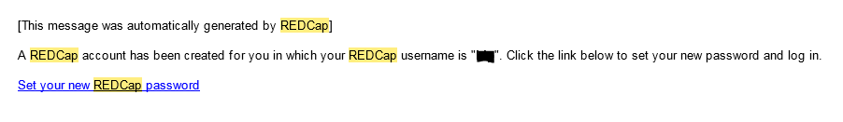

Please follow the link to create a password for this account.

The link will bring up REDCap two-step login. Choose the Email option to receive the verification code needed to complete the password setup.

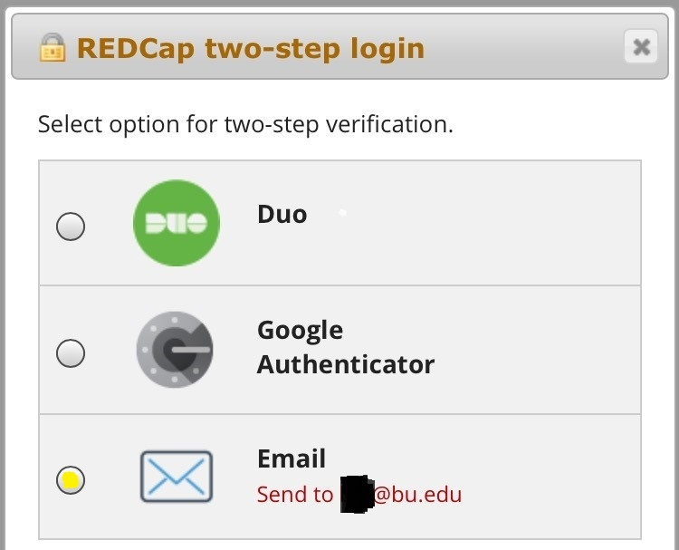

The first time, users *must* use the email method to verify their two-factor authentication. After logging in, users may set up additional methods of authentication that can be used during subsequent logins (see the section ***Two-Factor Authentication*** below, for additional details about how to set up and use these other methods of authentication.)

Selecting the “Email” option will trigger REDCap to send the user an automated email with the verification code:

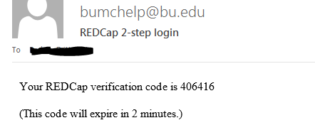

Enter the verification code emailed to you to create and confirm your password.

Each user is assigned a unique username when their REDCap account is created. Do not share your password with anyone. You are responsible for any data entered under your username.

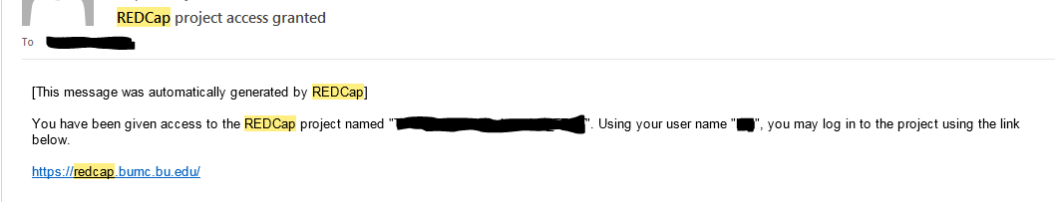

The BEDAC team grants access to individual REDCap projects and assigns appropriate project user roles and site-specific data access groups. When a user is added to a REDCap project, an email confirming the new REDCap project access will be automatically sent via REDCap to the newly assigned user.

## Permissions

Different investigators and site staff may have different permissions, which will affect the links they see and the actions they can perform in REDCap. In general, all site staff will be able to view and enter data. The NeoQIC team at BMC manages user permission settings. Please contact the BMC team if updates need to be made for any user at your site.

## Logging in

The REDCap website may be accessed via <https://redcap.bumc.bu.edu/>.

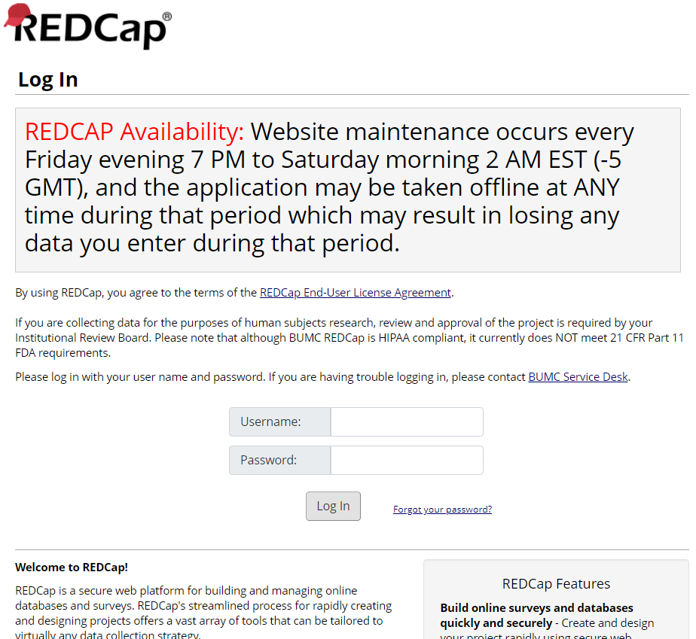

If you forget your password, select the “Forgot your password?” hyperlink to the right of the “Log In” button to reset. If you continue to have difficulty logging in, please contact BEDAC (see contact info above, in section II. Contact Information). You will be automatically logged out after 20 minutes of inactivity.

Please log out of REDCap when you leave your computer.

## Two-Factor Authentication (2FA)

REDCap uses two-factor authentication (2FA) for increased security. There are three different methods of secondary authentication: DUO, Google Authenticator, and email.

The first time you log in to REDCap, you must use email as the secondary authentication method. This is because you must be logged in to REDCap in order to initially set up DUO or Google Authenticator for REDCap.



We will use only the email method in detail below during training but details are provided below for the DUO and Google Authenticator versions if you prefer to use one of those apps.

### DUO

To set up DUO authentication, you must first log into REDCap (using email for 2FA). Click on “My Profile” in the upper right hand corner, scroll down to “Login-related options”, and follow the directions for setting up DUO authentication. This only needs to be done once.







Once you have DUO set up for REDCap, there are three ways in which DUO can be used for 2FA: mobile phone, tablet, and landline. In each option, simply enter your number and you will get a verification code. Enter the code to log in. If you have the DUO mobile app installed on your mobile device, you may choose to use “Duo Push”, in which you tap on your mobile device to confirm authentication rather than manually typing the verification code into the REDCap website.

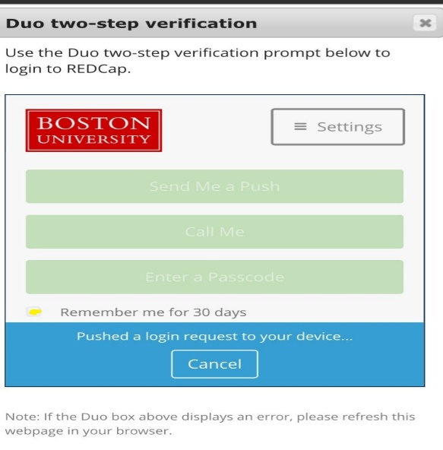

If you have the DUO mobile app installed on your mobile device, you may also see a checkbox at the bottom of the two-step verification pop-up box that allows you to save your secondary authentication for 30 days. Selecting this may save you considerable time if you access REDCap frequently from the same device.

### Google Authenticator

To set up Google Authenticator, you must first be logged in to REDCap (using email as secondary authentication). Click on “My Profile” in the upper left hand corner, scroll down to “Login-related options”, and follow the directions to set up Google Authenticator.

If you have the Google Authenticator app installed on your phone or mobile device, you can also verify through the app after you have gone through the one-time initial setup from your REDCap account. By selecting this 2FA option when logging in subsequently, you may enter the Google Authenticator verification code in REDCap’s 2FA pop-up window in order to authenticate.

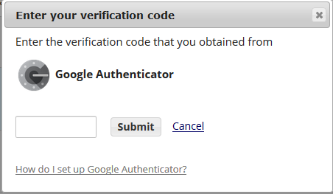

### Email

This is what we will be using during the training, and is the method you must use the first time you access your REDCap account. **You will need access to your email account**.

Select the “Email” option on the 2FA pop-up box and a verification code will be emailed to you at the email address used to create your REDCap account. The emailed code expires after 2 minutes, so it may be helpful to have your email account open when you initially log in.

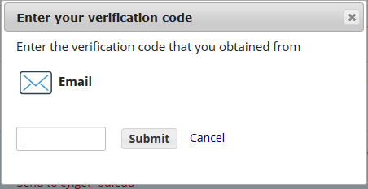

You will always have to use email the first time you log in, because you need to be logged in to REDCap to set up secondary authentication using DUO and Google Authenticator.

If you consistently plan to use email as your 2FA method and notice you do not have enough time to enter the code because of email delays, please contact BEDAC (see contact info above, in section II. Contact Information) to request that the expiration period be extended for your account. This must be done on a user-by-user basis.

## Account suspension and REDCap downtime

### Account suspension

If a user does not login to REDCap for 180 days, their account is automatically suspended. To unsuspend your account, please re-complete the online REDCap end user license agreement (EULA) which is linked on the BU REDCap login page. If you need assistance, please email BEDAC (see contact info above, in section II. Contact Information).

### Website timing out

As a security measure, the REDCap website will enforce a timeout: if the user has not clicked on the REDCap page (for example, moving from one field to the next) for approximately 20 minutes, the user will automatically be logged off. If the user is automatically logged out in this way, data may be lost if the user did not click on a “Save” button to save their data before taking a break.

We strongly encourage staff to save their work before addressing any interruption to the data entry flow. See the “Saving Data” section in the “Data Entry” part of this user manual for tips and tricks for easily saving REDCap data.

If the website times out due to inactivity, this pop-up message will display:

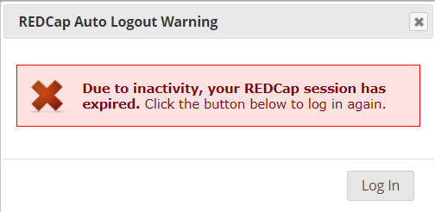

Logging in again will return you to the page you were on, but you may have to re-enter data if the “Save” button had not been clicked prior to timeout.

### Maintenance periods

BU’s installation of REDCap is scheduled for routine maintenance every Friday night (7 PM Friday to 2 AM Saturday, Eastern time). There is a warning on the login page to remind users every time they log in to REDCap. During that scheduled downtime, it is possible that entered data may NOT save properly. We advise users to avoid using REDCap during this weekly maintenance period.

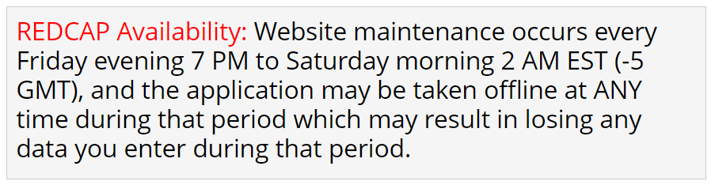

## Accessing the NeoQIC project

Once you have logged in, your NeoQIC REDCap project will be available for entering, editing, viewing, or cleaning participant data, depending on your user permission settings. Project appearance and functionality will be dependent on user role as well.

The TEST project name is: **NeoQIC - FOR PRACTICE ONLY**

The LIVE project name is: **NeoQIC**

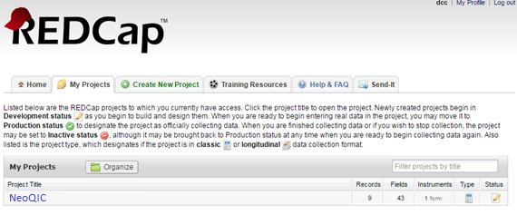

Select your project

|  |
| --- |
| **IMPORTANT** |
| **Prior to study start, you will be given access to the test project to conduct training sessions and enter test data. Only test data should be entered in the test projects (clearly labeled “-FOR PRACTICE ONLY”); only real data should be entered in the live project.** |

### Navigation within the NeoQIC project

This project collects chart review and survey data, provides data cleaning functionality through data quality checks, and provides basic reporting on NeoQIC data.

Throughout the NeoQIC project, users will only be able to see data from their own site. Additional functionality may also be different by user role.

After clicking on the project name, users will see that project’s home page, with an extensive navigation bar on the left. The contents of the left navigation bar may differ slightly based on user permissions, but will generally contain these sections:

* (General REDCap links at the very top)
* Project Home and Design
* Data Collection
* Applications
* Project Bookmarks
* Reports
* Help & Information

Each section within the left navigation bar starts with a dark gray header row. That dark gray row has a horizontal bar icon at the right side, which can be clicked to hide all components within that section. If the components are hidden, the horizontal bar icon turns into a plus sign icon. This may be helpful to streamline the look of the left navigation bar if there are sections that are seldom used. The components hidden in this way can always be shown again by clicking the plus sign icon that now shows to the right side of that dark gray section header row.

#### General Links

At the top of the left navigation bar are general REDCap links followed by the “Project Home and Design” section.

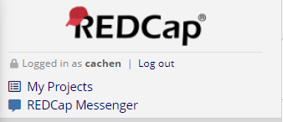

Just under the REDCap logo, are the username of the person currently logged in, and a quick link to log out of REDCap.

Below that are links to return to the user’s “My Projects” listing of all REDCap projects they have access to, and “REDCap Messenger”, a way to communicate with colleagues within REDCap. Occasionally, system wide alerts will be disseminated via REDCap Messenger and users will see a red alert next to the REDCap Messenger icon to indicate there are unread messages waiting to be read.

#### Project Home and Design

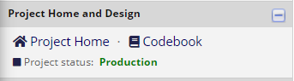

The Project Home and Design section includes links to quickly navigate to the project’s home page, and to view the project’s codebook.

#### Data Collection

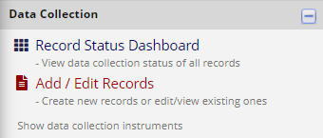

Select to add a new interview

Select to view all interviews

This section will be most useful for data entry and for displaying a quick overview of interview status for all interviews.

The Record Status Dashboard shows the status of all interviews at your site in one large grid. Each row represents a separate interview, and the color-coded circles provide quick visual representations of incomplete, complete, and locked forms.

Select “Add / Edit Records” in order to create a new interview, or to view / edit a specific interview where you know the REDCap interview number.

#### Applications

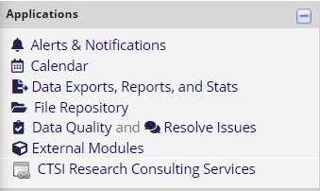

The items shown in this section may vary by user permissions. For example, most site staff do not have permission to execute data quality checks and will not see the “Data Quality” link.

For NeoQIC, the most often used links in this section will be “Data Exports, Reports, and Stats” for reports and “Data Quality and Resolve Issues” for data cleaning. These are explained in much more detail below.

The other link that may be helpful is “File Repository”. Documents such as user manuals may be saved here for your reference.

We do not encourage the use of the other links at this time; some of them are for REDCap programmers only. If you have specific questions about the other links and whether their functionality may be useful for your site, please ask BEDAC *before* making any edits.

#### Project Bookmarks

This section contains administrative links. Please do NOT edit or add to this section. It might be a good idea to hide this section by clicking the horizontal icon at the right of this section header.

#### Reports

This section lists all reports that are currently available in REDCap. Reports will be based only on data from your site.

Click on the name of the report you wish to view to open that report, or to view the tab listing standard reports available through REDCap. Reports are discussed in more detail below, in section VIII. Data Cleaning and Reports.

#### Help & Information

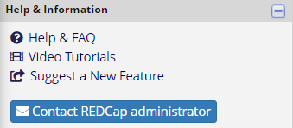

General REDCap training resources and FAQs are available in this section. These resources are not project-specific, but may be useful in learning how to use REDCap or resolve technical difficulties. It includes a link to email the BU REDCap administrator (note that this instance of REDCap is not managed by BEDAC).

### Accessing data

There are two ways to access a specific interview.

1. Select **Add/Edit Records** from the Data Collection section to access a previously entered interview, or to add a new interview.
2. Select **Record Status Dashboard** to view all previously entered interviews at your site. Double click on the ID of the record you want to view.

#### Add/Edit Records

Select **Add/Edit Records** and add a new interview or select a previously entered interview.

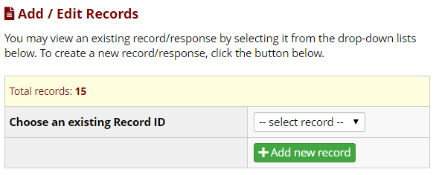

Add a new REDCap ID

Select a previously entered REDCap ID

After clicking on “Add new record” or selecting a previously entered ID, the Record Home Page view is displayed: an ID-specific grid of data collection forms and colored status icons indicating the data entry status for each instrument.

Click on a status icon (colored bubble) in the Record Home Page grid to open that data collection instrument.

When a data collection form is open, a menu of instruments for the selected participant is simultaneously shown in the left margin: a list of forms for the selected interview. This navigation pane allows users to move directly to other forms for the same interview record ID.

Open data entry form

#### 

Left navigation pane

Open data entry form

#### Record Status Dashboard

Alternatively, by selecting **Record Status Dashboard**, the user will be presented with a status grid that displays all previously entered REDCap interview IDs, all forms for those IDs, and the data entry status for every form. Users will only see IDs from their own site; REDCap record IDs are unique across all sites.

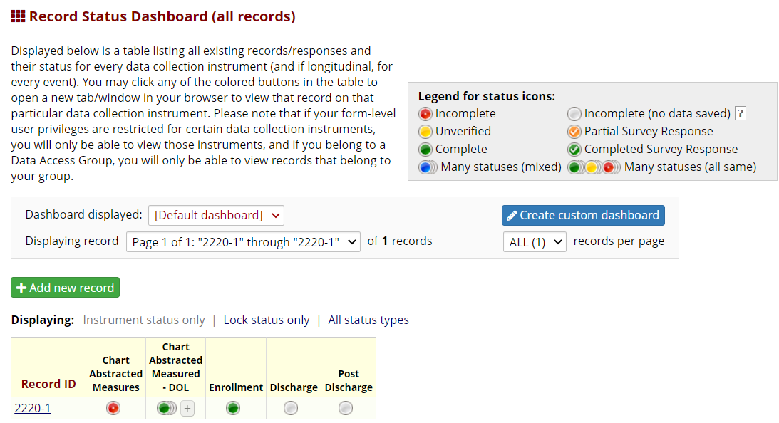

**Incomplete** 🡪 Data entry needed

**Unverified** 🡪 Data entry needed

**Complete** 🡪 Form is completely entered

**Incomplete (no data saved)** 🡪 No data / module

not assigned

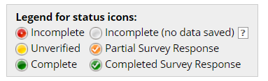

After selecting a status icon (colored circle), the user will be presented with the specified data entry form for that interview. Again, the Data Collection menu in the left navigation bar will list all data collection module for the given interview. After completing a module, the user may navigate between these forms by clicking on the form name in the left navigation bar.

|  |  |
| --- | --- |
|  | **TIP**: Set the record status to “unverified” to indicate that data entry has been started but some additional data cleaning or verification is needed. Once data entry and cleaning are complete, change the form status to “Complete”. |

### Navigation Tips

The forms in the Record Status Dashboard are displayed in a grid that shows each ID in its own row and the forms as columns. In the participant-specific Record Home Page, showing only one participant ID, the forms are shown as separate rows.

Click on a status icon (gray or colored bubble) in the Record Status Dashboard or Record Home Page grid to open that data collection form.

|  |  |
| --- | --- |
|  | **TIP**: By clicking on the colored dots on the record home page or left navigation pane, you can navigate between instruments without having to re-enter the interview record ID. |

|  |  |
| --- | --- |
|  | **TIP**: By clicking on “Select other record” in the left navigation pane (next to the interview record ID), you can navigate between interview records without having to return to the home page. |

# Data Entry

Use the data entry form view for NeoQIC chart abstracted measures rather than the survey view, in order to be able to enter comments. Enter the data entry view simply by selecting the link with the form name (when within a specific data entry form, using the left navigation bar under the “Data Collection” section), or by clicking on the colored circle next to the form name from the record home page or record dashboard view.

### Data entry tips

|  |  |
| --- | --- |
|  | **TIP**: Use your mouse or “Tab” key to move from field to field   (Note: pressing “Enter” will save your data but kick you out of the form.) |
|  |  |
|  | **TIP**: Do NOT use the keyboard arrow keys to try to move from field to field; arrow keys will instead move within answer options in the selected question. |
|  |  |
|  | **TIP**: Do not use the browser arrows to move back and forth between screens/forms or you will lose data. |
|  |  |
|  | **TIP**: Confirm that you are entering data for the correct interview by checking the ID at the top of each page. |
|  |  |
|  | **TIP**: If you need to clear a radio button, use the “reset” button to the right of the question.    If resetting a field invalidates some of your later responses (the skip pattern has been compromised), then you will receive a REDCap pop-up warning asking for confirmation of the change, and warning you that your previous entry will be deleted. If you intentionally changed your response, then click “OK” and continue. An example of such a warning: |

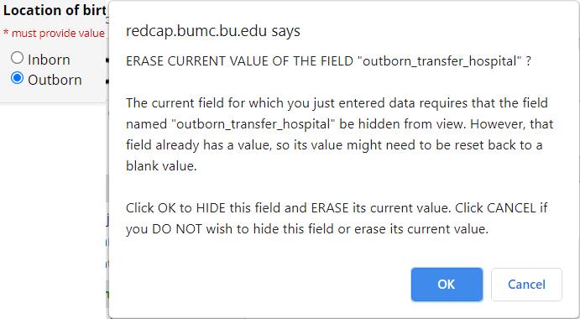

### Saving data

Note that REDCap does not save data until you either use your keyboard’s “Enter” key, or you click on a “Save” button in the form status section. Using the “Enter” key on your keyboard will save your data; it will also close the data entry screen, so it is best to **TAB** between fields, instead of using the “Enter” key.

Select the status of the form—incomplete, unverified, or complete, in the Form Status field at the bottom of the form. The status icon color on the menu will change to reflect the change in status.

Select a “Save” button to save your data. Save buttons appear at the bottom of each form.

Select form status

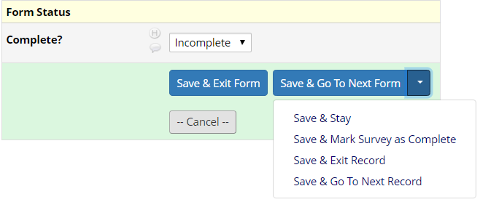

Save & continue to the next form/module

Save and exit

Exit without saving

Save and remain on this page

In addition to the “save” buttons at the bottom of each form, you may also use the save buttons that will always appear to be “floating” on the top right of the data entry screen. This is particularly helpful if you want to “Save & Stay” before a brief break, to ensure data entered so far is saved in case of website timeout (after 20 minutes of inactivity).

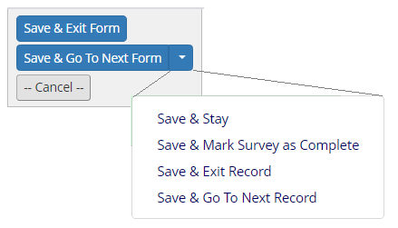

Note that the form status variable is only shown at the bottom of each form, however. If you want to change the form status from the default “Incomplete” (red circle on the record dashboard), you’ll want to scroll down to the bottom of the form to update this default value.

|  |  |
| --- | --- |
|  | **TIP**: Set the form status to “unverified” to indicate that data entry is complete but additional clarification is needed. Once data entry is complete and all data queries are resolved, change the form status to “Complete”.  (If there is no additional data verification needed, immediately set the form status to “Complete” once data entry is complete.) |

After saving a form, a pop-up box will appear if a required response is missing. REDCap will save incomplete data, but if possible, return to the form by clicking “Okay” and finish entering the data.

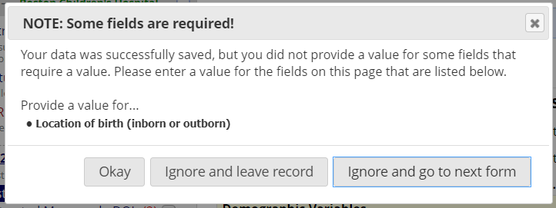

### Useful data entry features

#### Entering dates

A calendar function is available for entering dates or date and time, as needed. Click on the calendar icon to display a calendar. (You may also type the dates or date and time, as required by the field.) The “Today” button allows instant entry of today’s date; the “Now” button allows instant entry of the date and time that the button was clicked.

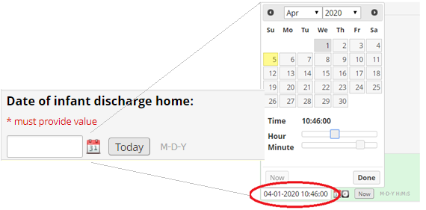

It is often faster to click the “Today” button to automatically fill in the date as of the moment the button was clicked.

#### Warnings

Warning messages have been programmed to alert you to data inconsistencies and other information important to the user. REDCap system messages will appear if text is entered into a numeric field, for example.

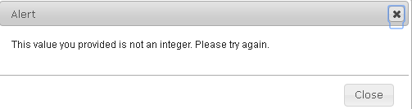

#### Skip patterns

Certain responses may trigger additional questions. In this example, “Other” is

selected for maternal race. The user is then prompted to specify in a text response, “Specify”, in a field that was not previously displayed.

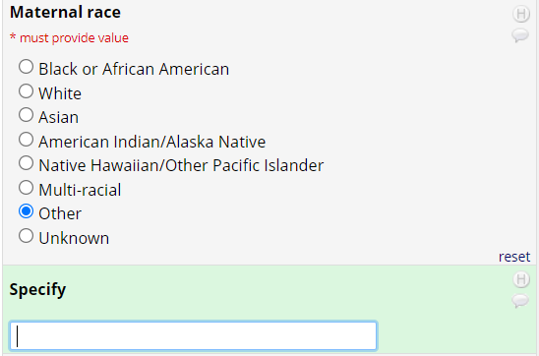

#### Logic checks

Where possible, data is compared and warnings are displayed if the logic fails.

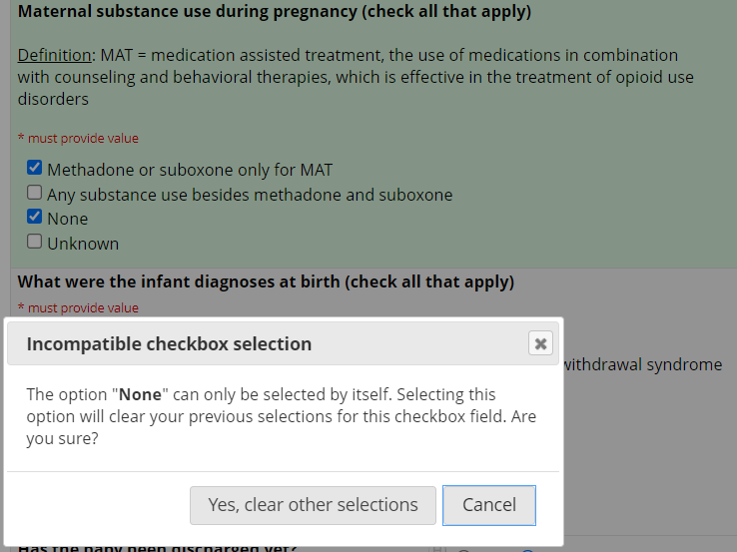

|  |
| --- |
| **IMPORTANT** |
| **REDCap will warn you when you have not answered required fields and when your data are out of range, but it cannot prevent you from saving your data with these errors.** |

#### Audit trails

REDCap saves audit trails: it is possible to see the date and time when data are saved, and by whom (REDCap username). Changes to saved values are logged when the updates are saved in the audit log, but can also be seen by clicking on the “H” next to any field. This shows the audit trail history of that specific field.

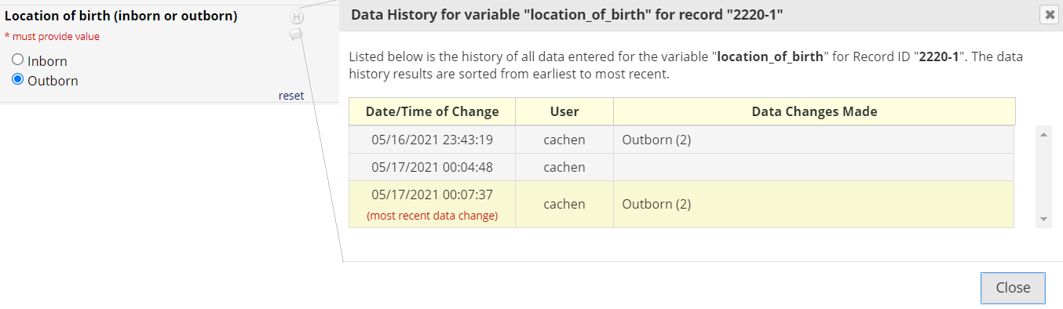

## Enter a new participant: step by step instructions

1. Log in to REDCap. (See Section VI.)

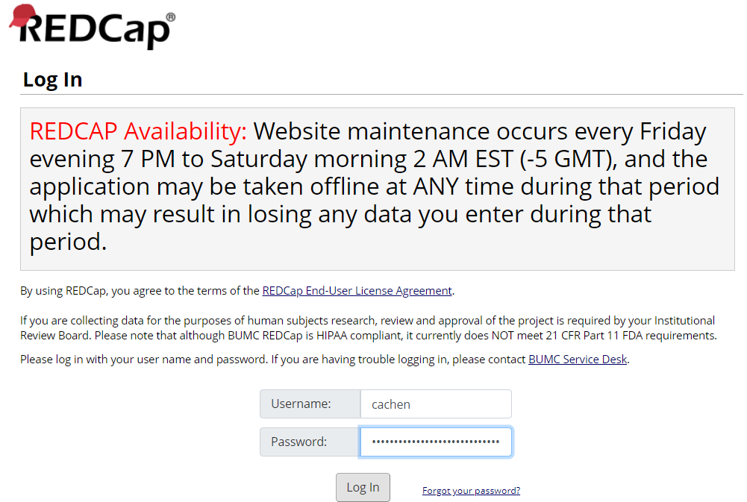

1. Click on “My Projects” in the top navigation bar.
2. Select the “NeoQIC” project to enter real data, or select the “NeoQIC – FOR PRACTICE ONLY” project if entering *test* data.
3. On the left navigation bar under “Data Collection,” click **Add / Edit Records**. You will be brought to the screen below. Click on “Add new record” to start a new interview.

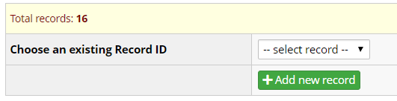

1. A new survey Record Home Page will open, with green text confirming that a new record is being created. The record ID for the interview is automatically generated by REDCap and cannot be changed. On the Record Home Page, click on the gray circle next to the first (topmost) data collection instrument (Chart Abstraction Measures) to open that form and begin entering data.
2. Answer all questions on the form. If there is any confusion about responses, please add a comment on the appropriate question by clicking on the speech bubble next to the form question and enter your comment. Don’t forget to click the button in the lower right corner of the pop-up box to save your comment or query!
3. There are special instructions for the Day of Life table – please refer to the section below entitled “Using the Day of Life Table”.
4. When you have finished entering data on the form, set the form status question at the bottom of the form to “Complete” (or “Unverified” if data entry is not complete for the form yet). If your data entry is interrupted, we recommend leaving the form status as the default “Incomplete” as a prompt for later completion.
5. Click on “Save & Exit” to return to the participant’s Record Home Page, or click on “Save & Go to Next Form” to cause the next data entry form to automatically open.

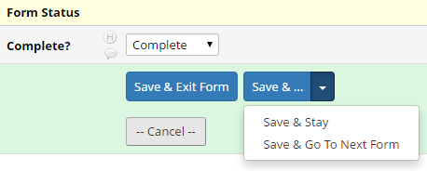

One could also click on “Save & Stay” which will save the data but stay on the same form. Clicking “Cancel” will exit the form ***without*** saving the data and return to the Record Home page.

# Using the Day of Life Table

## Introduction

The **NeoQIC** project has several variables that are collected multiple times for a given patient. This data collection is done on a daily basis, but not for every day of a patient’s stay. To manage this, a form called **Chart Abstracted Measures – DOL** collects Day-of-Life (DOL) specific data. The following section explains how to create a record and collect data abstracted from the charts for both general and DOL-specific data collection.

## Creating a Record

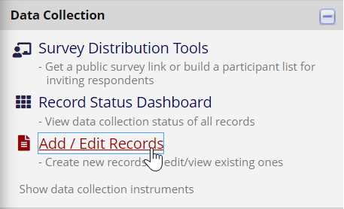Once in the REDCap, the **Left-Hand Column** is where you will find links to all parts of the project. To create a new record (that is, for a new patient), you can use the **Add / Edit Records** button. (The **Record Status Dashboard**, located above it, will show you a view of all records in the project from your institution.)

Once on the **Add / Edit Records** page, you can create a new record with the **+ Add new record** button:

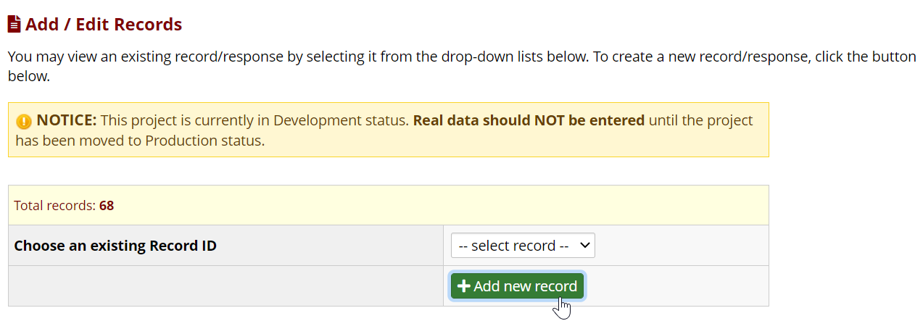

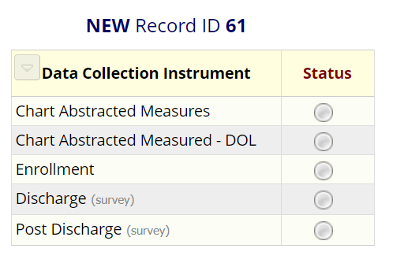This brings you to the **Record Home Page**, where you can see the **Data Collection Forms** in the record. As this is a new record, the **Status** circles start out empty; once data is saved for each form, a color will indicate whether the form is complete. To enter a form, you can click on the corresponding circle. For now, start with the first one, **Chart Abstracted Measures**.

## Recording Data

Now that you are in the data collection form, you will see instructions for how to fill it out, followed by questions whose data should be abstracted from the patient’s medical charts. Fill these out to the best of your abilities- if a field says **\*must provide value** you will be prompted to fill it in before saving the form; that said, you are still able to save a form even without these.

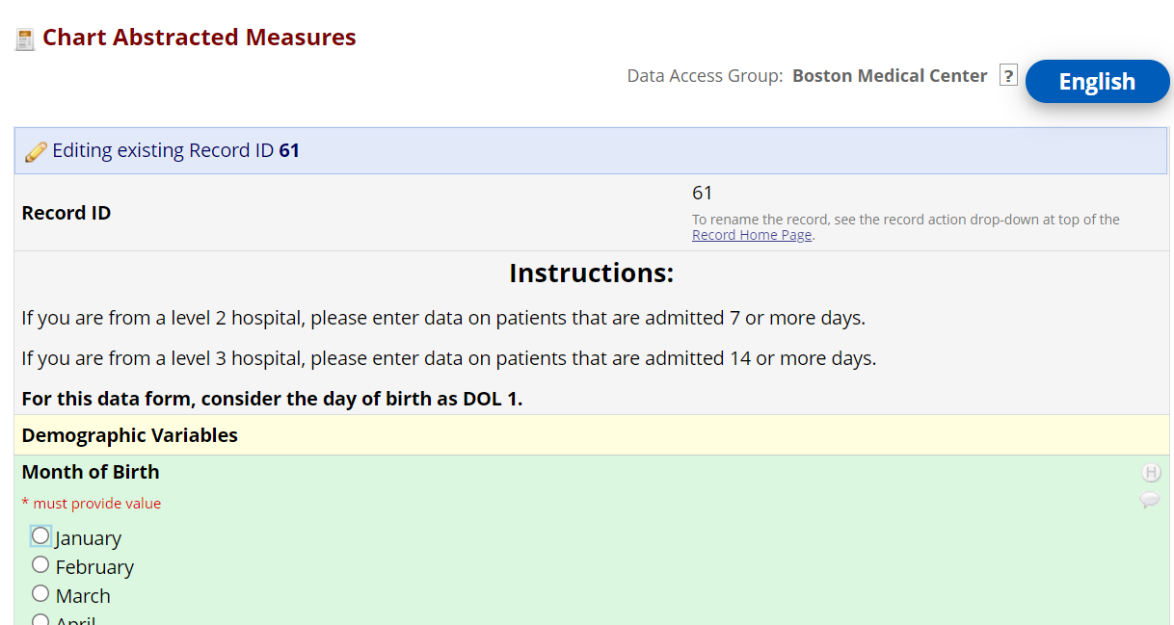

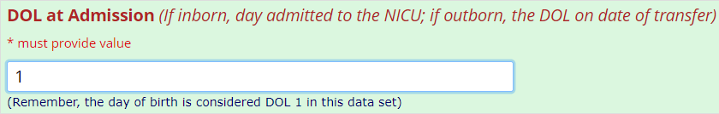However, one question, called **DOL at Admission**, *is* needed to record DOL-specific data:

## The Day of Life Table

At the bottom of the page, following all other questions, is a table for the Day-of-Life specific data. This table will start out empty, and to use it you must first save the record by pressing one of the save buttons (**Save & Exit Form** or **Save & Stay**). Note that the warning in red will appear whenever the form status is **Incomplete**, regardless of whether it has been saved.

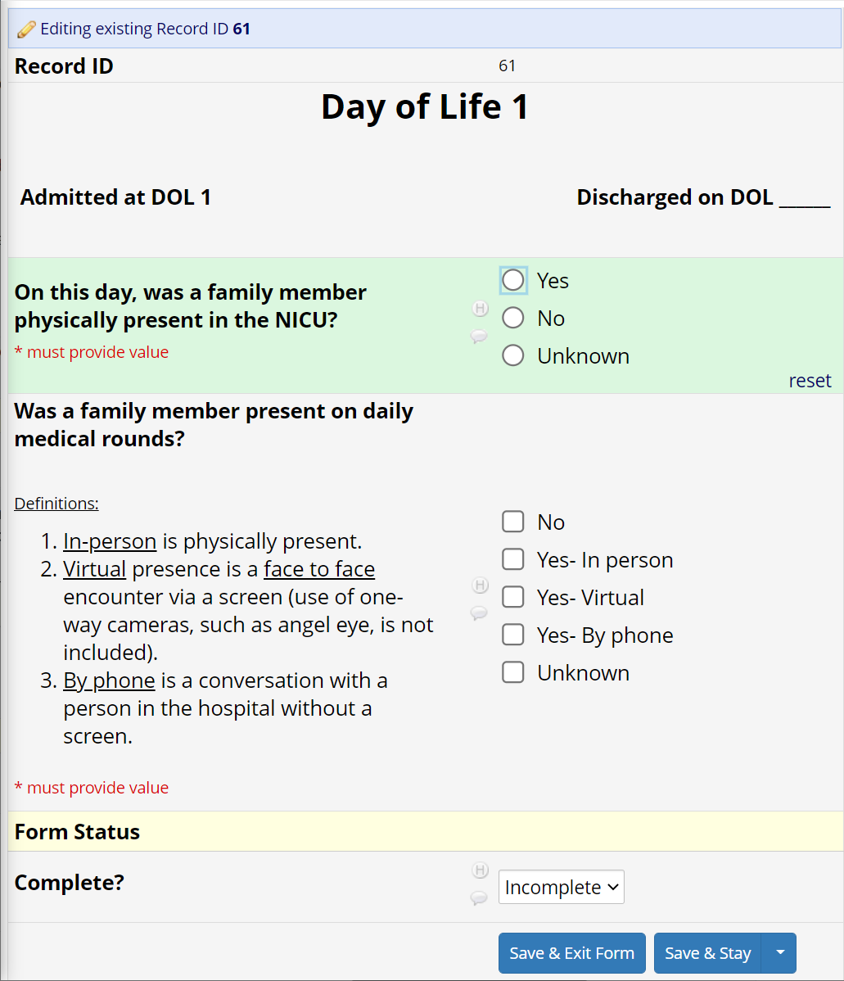Once the form *is* saved, pressing the **+ Add new** button will launch a new window (or tab) with questions that are specific to a patient’s Day of Life. The first time you launch this, the Day of Life on the form will always be the Day of Life of the admit.

You can use this form even before the patient has been discharged (or if the **Day of Discharge** is unknown), however, it will only let you enter data for the **first seven days** that the patient was in the NICU. If the date of discharge is known, it will be shown on the form, and you will not be able to enter data for any day of life after the discharge.

Once data is entered for this Day of Life, you can mark this form as **Complete** and save the form. Clicking the small arrow next to **Save & Stay** will give you a new option called **Save & Go To Next Instance**, which will open this form for the next allowed Day of Life:

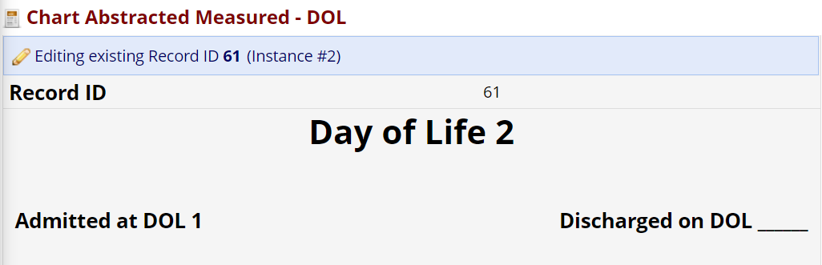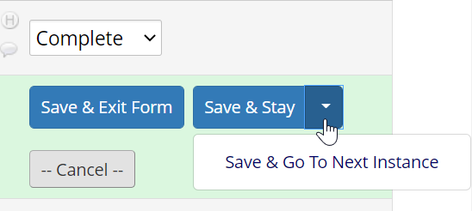

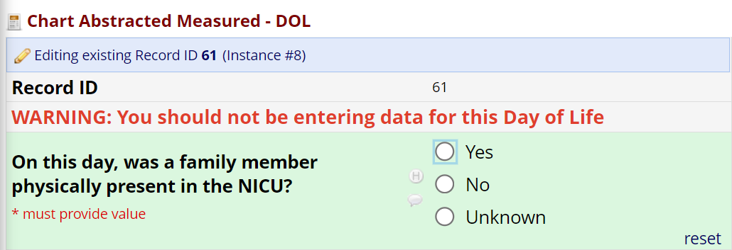You can continue filling out these forms until you get a warning that you should not be filling out data for the given Day of Life; if you see this warning *do not continue* to fill out the form, as doing so will mess up the order of the Days of Life in the system.

**For reference:** Before a baby is discharged, you should be able to enter data for their first seven days after admit; following discharge you will be able to enter data for Days of Life 22-28 (if they were in the NICU then) and their last seven days in the NICU before discharge.

Once data has been saved for at least one instance of the Day of Life form, the table on Chart Abstracted Measures will populate with some of the data from it. Clicking on the number below **#** will take you to that instance of the form. Note that the # of the form will always be sequential, whereas the **Day of Life** column will show which Day of Life the data is for; these will generally *not* match, particularly if the patient is not admitted on their first Day of Life, or after their first seven days of life.

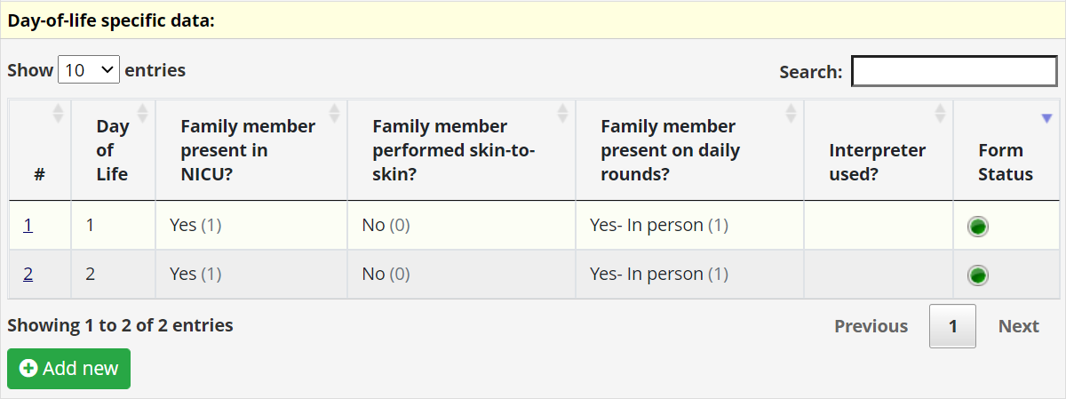

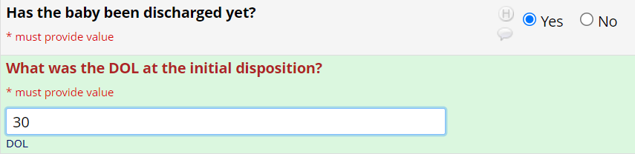Once the patient has been discharged yet, answering **Yes** to this question will ask you what Day of Life the discharge was. It will also show you more questions about the patient’s entire stay at the hospital.

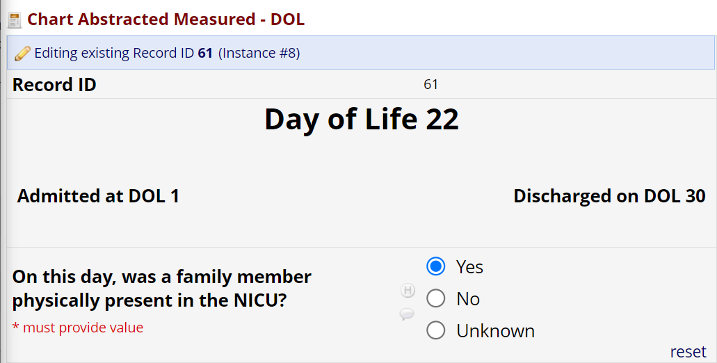Once the DOL for the initial disposition has been entered, more days will be allowed when you press + Add New in the DOL table, following the pattern stated above. These will also appear in the table once saved; the table allows you to go through pages of filled-in data or expand its size to show all of them.

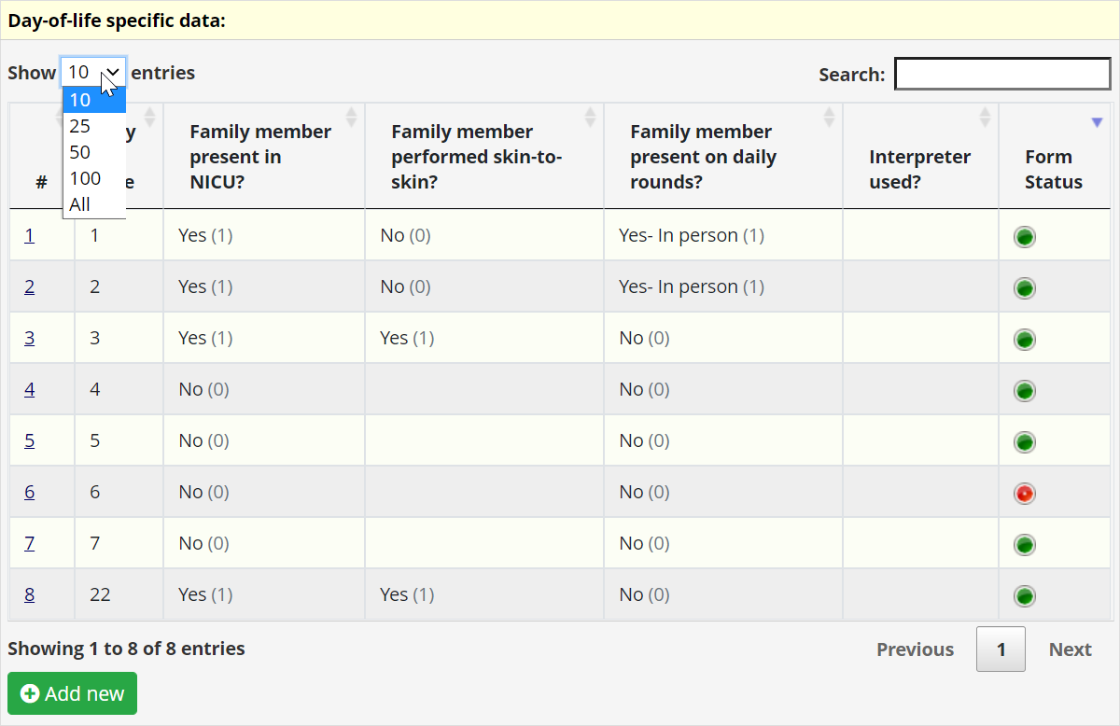

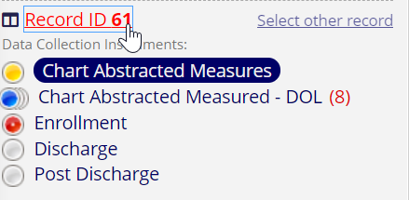In addition to the Day of Life table, you will also see how many DOL-specific forms were filled in in the left-hand column, as well as on the Record Home Page, which will have a list of completed DOL-specific forms you can click on to enter and edit.

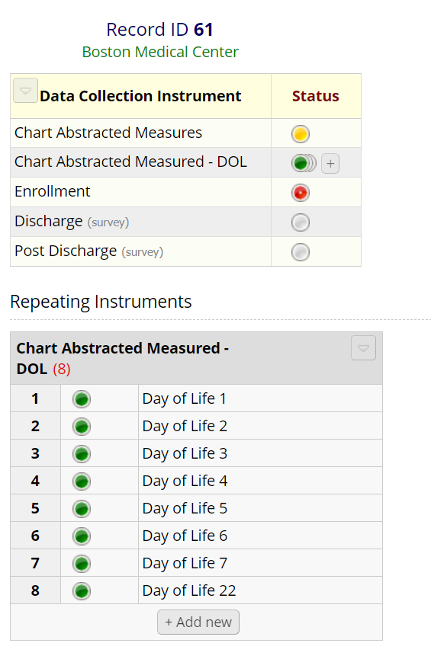

# Sending Out Survey Invites

## The Enrollment Form

Once **Chart Abstracted Measures** has been saved at least once, you will see that the **Enrollment** form is red (that is, **Incomplete**) in the left-hand column and Record Home Page. This form is used to send out the two surveys, called **Discharge** and **Post-Discharge**, respectively, to the patient’s caregiver(s). To access the form, you can click on the dot next to it.

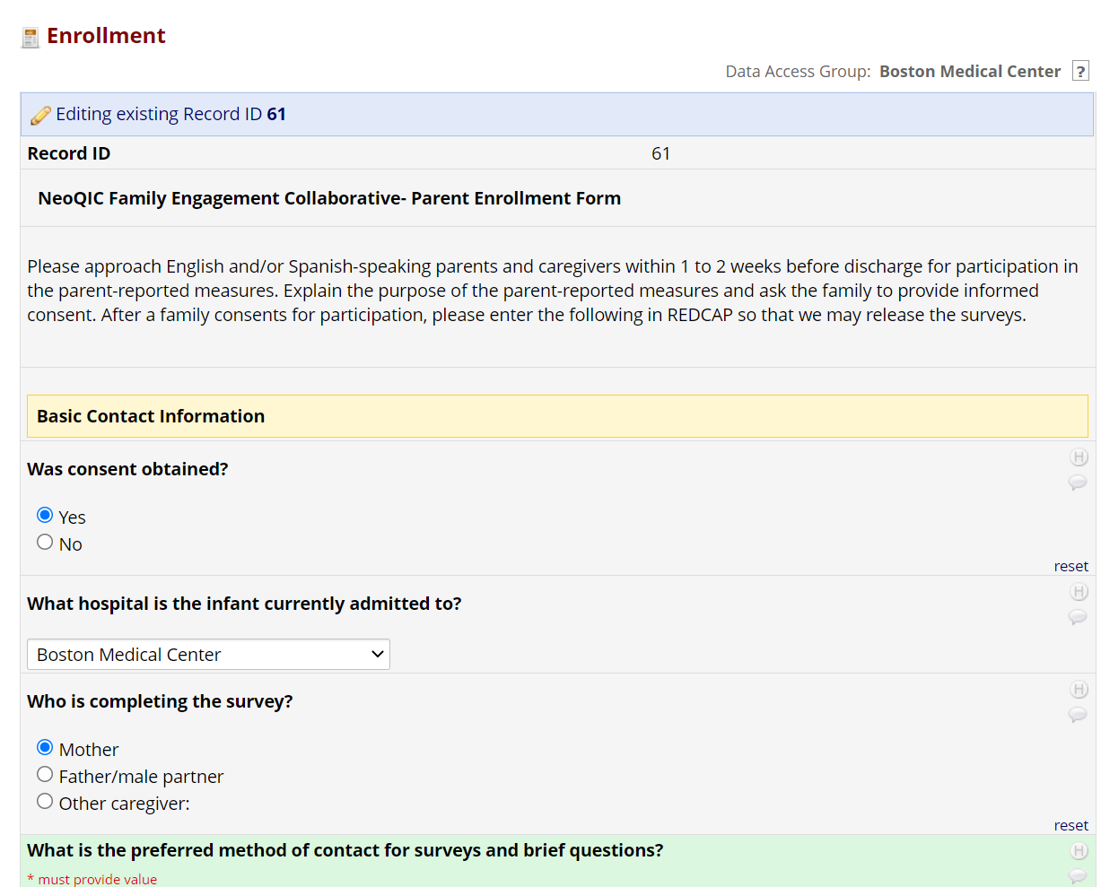Once in the Enrollment form, you will see instructions for filling it out and questions about whether consent was obtained, when the discharge occurred, and the caregivers’ contact information. As these surveys are meant to be taken only after the patient has discharged, you do not need to fill out this form until then.

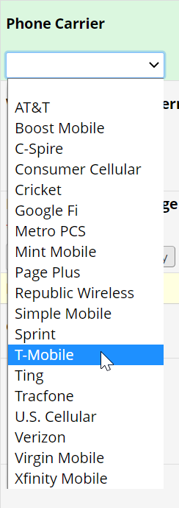For the contact information, you must select whether you would like to use texting or emailing to send the surveys out. Note that to use texting, you must know the caregiver’s phone carrier. You must also make sure to enter the phone number as a ten-digit integer without hyphens, spaces, or parentheses.

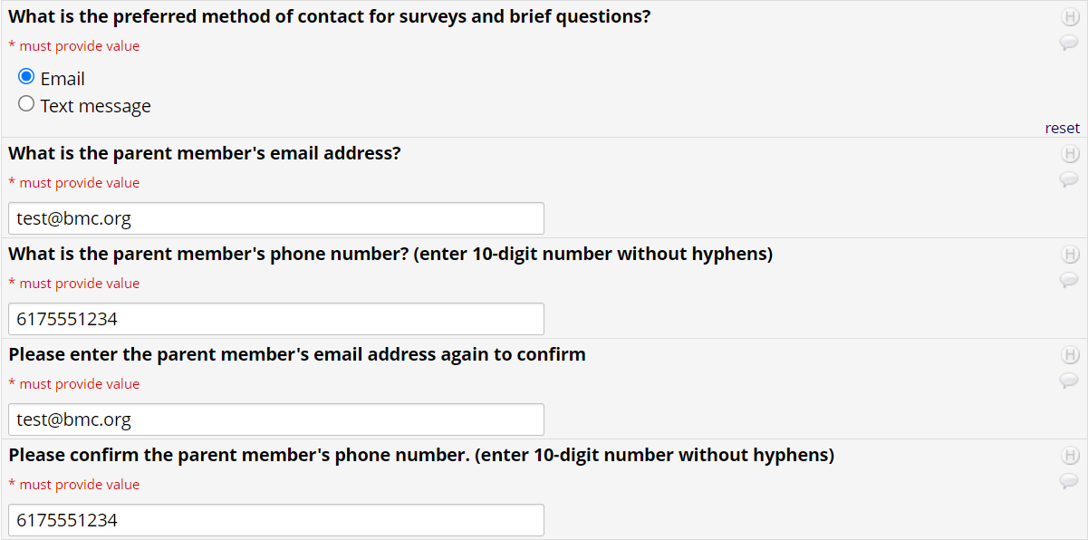

For the surveys to be sent, all fields must be filled in on the enrollment form. The first survey, **Discharge**, will go out one day after the patient is discharged; the second survey, **Post-Discharge**, will go out 28 days after discharge.

## Viewing Alerts / Surveys Scheduled

Invitations for the caregivers to take the surveys are handled through REDCap’s **Alerts & Notifications** section (*not* Survey Distribution tools, which is more often used by other REDCap projects). This section is accessible via the left-hand column.

Note that even if you have access to this section, you should *never make any changes to the alerts****.*** This section of REDCap is to be used solely for viewing what alerts have gone out, or will go out, and to whom.

Clicking on the Alerts & Notifications button brings you to a page that shows all of the alerts set up for the project. These include both Texts and Emails for both of the two surveys, with English and Spanish variants for each (Tufts Medical Center also has its own separate Text and Email alerts.) On each alert, you can see a list of records where they were sent out, or will be sent. A tab in this section brings you to the **Notification Log**, which has a tabular view of the alerts that have, or will be sent.

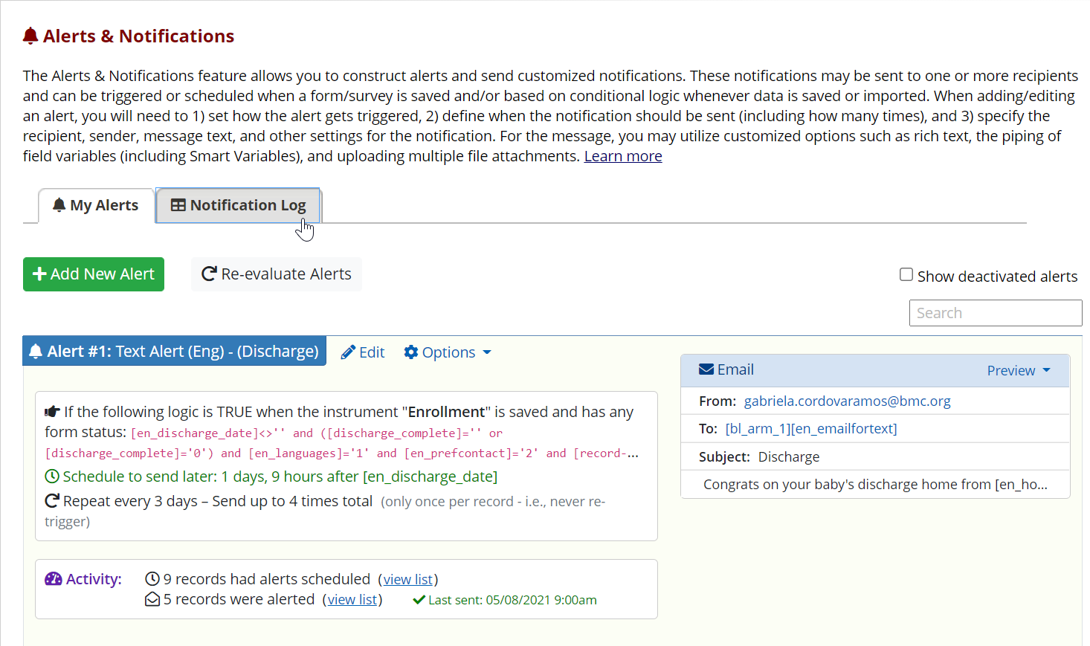

In the Notification Log, you can filter the alerts by type, which record, and the time range in which the alert went out or is scheduled to go out. You can also view what went out to each record to make sure that the information was correct. If it ever seems like a caregiver did not get a certain alert, checking when and where it was sent is a great place to start; if the caregiver still did not get an alert they should have, it may be due to spam filters, or a phone blocking unknown numbers (some carriers block robo-texts by default and need to be called to unblock these).

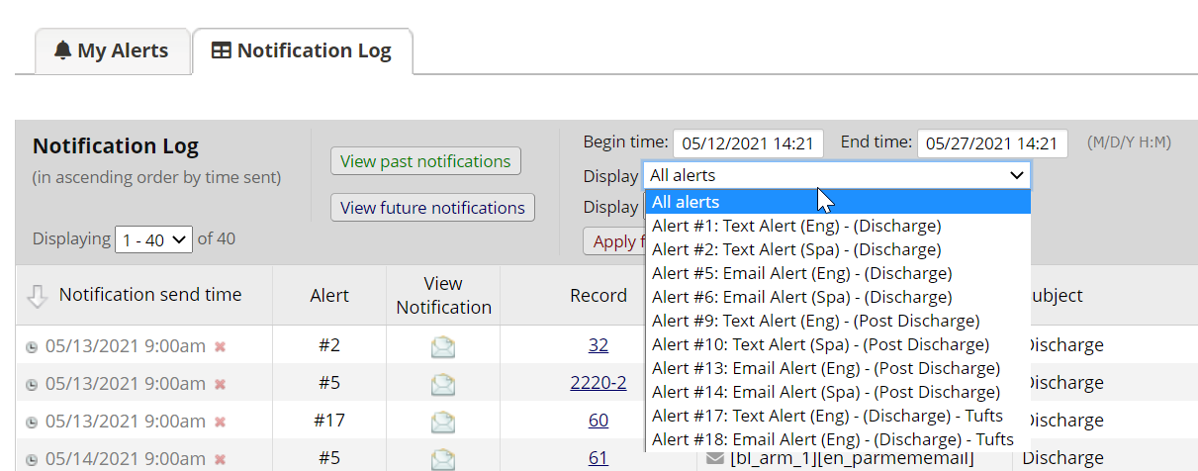

# Data Cleaning and Reports

Data cleaning and reporting are built-in features in REDCap, and site coordinators are expected to review data quality checks and reports periodically in order to keep up-to-date on data cleaning. This section describes how to access and understand data quality checks, field comment logs, and reports to identify data cleaning that is needed, as well as how to resolve the discrepancies directly in REDCap.

### Data quality checks

Data quality checks are used to identify data discrepancies and facilitate data cleaning.

To access the data quality checks, click on “Data Quality” in the left navigation bar under the “Applications” section.

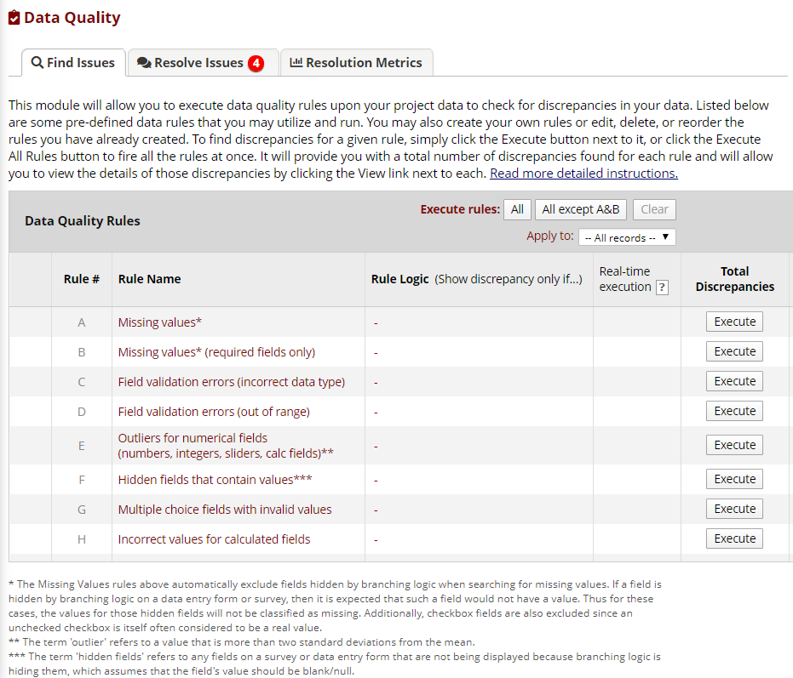

There are a number of built-in data quality rules (A through H), and more can be added by BEDAC as necessary. Please contact BEDAC if you have requests.

For each data quality rule, there is an “Execute” button which, when selected, will calculate a list of all interviews and instances where the data quality rule is true. The results are returned as a number (in red font if any were found, a green “0” if none were found). Note that rules A and B, for missing values, can take a long time to run.

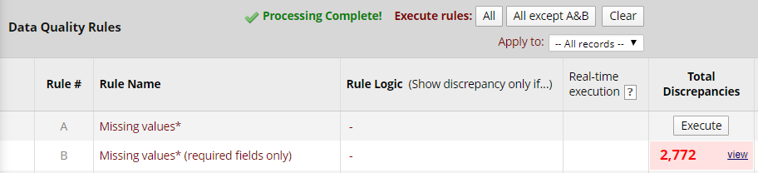

Click on the “view” link next to the number in order to see a listing of instances where this rule is true. For example, for the missing values in required fields (for this very messy test data!), the listing begins:

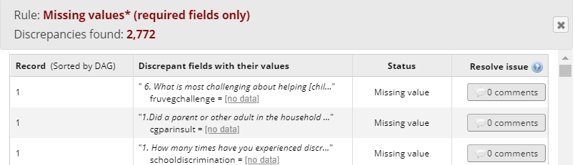

Click on the gray discrepant value listed in the second column to navigate directly to that question, for that interview. The data can be updated and saved on that form, or from the data quality rule results by clicking on the comments box under the “Resolve issue” column.

|  |
| --- |
| **IMPORTANT** |
| **Do NOT use Query H, which recalculates incorrect values for calculated fields. This could result in changes to randomization assignments and other previously entered data.** |

### Reports

Reports summarize information saved in this REDCap project. Site staff will only see their site’s data reflected in the reports. Investigators who are not restricted to a specific site (or “data access group” in REDCap terms) will see data from all sites aggregated together in reports, with the option to dynamically filter results by site. Note that once a user is assigned to a data access group, they can never be moved to another data access group or to no access group in order to see all sites’ data.

To access reports, select the “Data Exports, Reports, and Stats” link in the left navigation bar under the “Applications” section. This will display a page of all available reports.

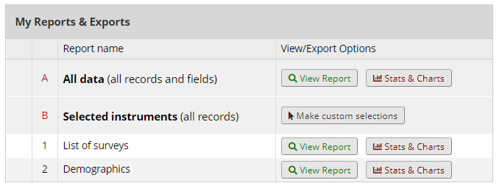

#### View Report

Click on “View Report” to see a tabular listing of all interviews and the variables selected for each report. This button is shown on the main “My Reports & Exports” page next to the report name as well as at the top of any open report.